ANNUAL REVIEW OF CHILDREN WITH NEUROFIBROMATOSIS TYPE 1 (NF1).

BM Dunning-Davies¹; APJ Parker¹
- Department of Paediatric Neuroscience, Addenbrooke’s Hospital, Cambridge, CB2 0QQ

Correspondence to: Dr APJ Parker, Department of Paediatric Neurology, Box 107, Addenbrooke's Hospital, Cambridge, CB2 0QQ Email: alasdair.parker@addenbrookes.nhs.uk

Contributorship Statement: The two authors are justifiably credited with authorship according to the ICMJE authorship criteria. In detail: BD-D – conception, design, drafting of manuscript, final approval given; APJP – conception, design, drafting of the manuscript, critical revision of manuscript, final approval given.

Key Words: neurofibromatosis type 1; NF1; neurocutaneous; annual review; secondary level.

Word Count: 3871

Aim
NF1, otherwise known as Von Recklinghausen Disease, is an inherited neurocutaneous, autosomal dominant, disorder affecting about 1 in 3000 children[1]. While it is primarily a neurocutaneous disorder its effects are wide ranging and other organs can be involved. There are a number of possible complications and the pattern of the disease varies greatly between individuals; despite this variation there are certain key common features that make clinical diagnosis possible. NF1 is distinct from NF2, which has a much lower incidence of cutaneous findings, a higher incidence of central nervous system tumours and a poorer prognosis.
NF2 is characterised by bilateral acoustic neuromas (vestibular schwannomas), and other tumours of the peripheral and central nervous system, mononeuropathies and cataracts. It is beyond the scope of this article to cover NF2, the incidence of which is more than 10 times lower than that of NF1. Its management differs significantly from that of NF1 with routine imaging playing a key role in surveillance and greater involvement of the tertiary NF2 specialist, particularly in the management of the more severe variants- which present earlier and with more atypical features. We would point the reader to other good reviews for guidance related to NF2[2]
Annual surveillance of children with NF1 is recommended to monitor the multi-organ manifestations. This is not a straightforward task for a paediatrician given the varied expression and low numbers of NF1 cases at secondary level.

We aim to provide a concise, evidence-based framework to assist secondary level, community and acute paediatricians during a 20-60 minute consultation. This review does not cover all aspects of the disorder. We recognise the importance of an overview of the pathogenesis, molecular genetic testing, clinical manifestations and management; we shall cover some of this briefly, but recommend further reading of other excellent recent reviews which focus on these areas. We focus instead on the following questions:
- what questions should be asked during annual review
- what should be included in a focused examination,
- when should further investigations be requested
- when should a referral be made to tertiary specialists and other members of the multidisciplinary team.

Ongoing debates regarding screening remain in certain areas, particularly regarding imaging and ophthalmology follow up; here we aim to summarise the differing opinions and make a recommendation based on the currently available evidence.

Genetics of Neurofibromatosis type 1.
NF1 is caused be a heterozygous loss of function mutation in the NF1 gene, which codes for a tumour suppressor, neurofibromin. It is an autosomal disorder but 50% of cases are secondary to de novo mutations. There is considerable variability both with different mutations and even within those carrying the same familial ones, indicating that the link between genotype and phenotype is not solely explained by the mutant allele; although there are a few exceptional mutations which lead to a consistent clinical phenotype[3]. Somatic mutations can lead to a mosaic form of NF1. If an early somatic mutation occurs then the phenotype can be very similar to non-mosaic disease, although it is invariably less severe; later mosaic mutations cause a more localised disease, which is often unilateral.

Confirming the Diagnosis
The diagnostic criteria for NF1 in general clinical use are those developed by the National Institute of Health (table 1) [4]. Most children seen at annual review will already have a firm diagnosis but one function of annual review is to confirm or reject a diagnosis. In some children NF1 will be likely but not confirmed; the child may be followed up to monitor for development of further signs. The features of NF1 accumulate with age and, therefore, while most children with NF1 by the age of 8 years meet the NIH criteria, younger children are less likely to do so. They may be monitored in clinic to see if they accumulate more features. Genetic testing is rarely needed for diagnosis, though occasionally may be used when the diagnosis is in doubt and there is a manifestation such as a large optic glioma where a diagnosis may affect treatment, or if counselling is required for family planning.

Table 1: Diagnostic Criteria for Neurofibromatosis Type 1[4]
A diagnosis can be made on clinical grounds alone when a child has two or more of the following criteria:
System | Features | Minimum number | Further detail
Dermatology | Café au lait | 6 | Greatest diameter:  >5mm if pre-pubertal  >15mm if post-pubertal
 | Axillary/inguinal freckling | n/a
Ophthalmology | Optic gliomata | 1
 | Lisch nodules | 2 | Also called iris hamartomas
Neurology | Neurofibromas | 2* | * only 1 if plexiform neurofibroma
Skeletal | Distinctive osseous lesion | 1 | Examples: Sphenoid dysplasia; tibial pseudoarthrosis.
Family history | First degree relative with NF1 | 1 | With diagnosis as defined by above criteria.

Natural history of NF1

NF1 is a progressive condition and features accumulate over time. The exact progression cannot be described as it varies greatly between individuals. However certain features are more common in different age groups. We have produced a timeline to illustrate the natural progression of the typical features, providing a guide on which areas need emphasis across a range of ages (Figure 1).

An overview of what an annual review should include?

The annual review should monitor for key symptoms and complications. Symptoms and signs may be elicited which indicate referral but, other than ophthalmological review, tertiary specialists need not routinely be involved.
The general consensus in the UK is that imaging is not required to monitor for complications or features of NF1 (with the exception of regular mammography in female adults from the age of 40) as it does not change management. It should be reserved for when there is diagnostic uncertainty or emergent complications. Imaging such as radiological survey for bone lesions, imaging of plexiform neurofibromas and echocardiography for congenital cardiac lesions is unnecessary in the absence of symptoms and signs suggesting a potentially significant finding. There is debate about the role of brain MRI in aiding the diagnosis of NF1 and in screening for optic pathway gliomas (OPGs)[5-7]. UBOs - “unidentified bright objects”, alternatively called focal areas of signal intensity (FASI) or focal abnormal signal intensity, seen on brain MRI imaging may aid diagnosis but currently these do not form part of the diagnostic criteria [8]. A retrospective cohort study by King et al showed no difference in outcome between patients with OPG, who presented because of symptoms or ophthalmic signs, and asymptomatic patients identified as a result of MRI[6]. Early diagnosis at the asymptomatic stage does not change management. MRI may require a general anaesthetic and the knowledge that a child has a “brain tumour” may cause significant anxiety and lead to pressure for repeated scans - which again may not change clinical management. The consensus therefore remains that baseline MRI and screening with MRI for OPGs is not warranted[5, 7]; it would only be considered for OPG detection if a child was completely unable to cooperate with ophthalmic assessment.

The annual review affords a vital opportunity to offer ongoing education and support to the child and their family, while allowing time to elicit their specific concerns and questions. Parents and children should, be involved in decisions about investigation and treatment. Some families will be highly informed and often have concerns that have arisen from what they have read which will need addressing. These issues need to be discussed. Families should also be directed to other sources of support such as the Neurofibromatosis Association. Written information is also useful to have to hand; the Neurofibromatosis Association (UK) (http://www.nfauk.org/what-is-neurofibromatosis/nf-type-1/nf1-info-sheets/) and The Children’s Tumor Foundation (USA) (http://www.ctf.org/Patient-Information/Patient-Information-Brochures.html) have useful downloadable leaflets (overseas ones will need adapting for use within the UK).

An annual review of a patient with neurofibromatosis type 1 involves checking for symptoms and signs in a number of systems. To facilitate this we will now go through each system separately and we provide figures 2 and 3 to act as a checklist.

Dermatology

The dermatological manifestations include café au lait patches, skin fold freckling, neurofibromas which may be cutaneous, subcutaneous or plexiform, and xanthogranulomas. While the first two are important in diagnosis, it is the neurofibromas which must be monitored because they are a cause of significant morbidity, including causing disfigurement, pain and paraesthesia.
Neurofibromas are benign tumours of the peripheral nerve sheath which accumulate with age. Cutaneous neurofibromas are papular and become pedunculated as they grow; they do not undergo malignant change but may still warrant removal. Occasionally they cause minor discomfort, but the main reasons for removal would be because they were often catching on clothes and bleeding, or for cosmetic purposes. When removal is considered, children should be referred to a plastic surgeon to discuss the risks which include hypertrophic scars and recurrence.
Subcutaneous neurofibromas can be palpated under the surface of the skin; they need more careful consideration as they have some potential for malignant change. They cause less of a problem cosmetically, but may be tender and cause paraesthesia in the distribution of the affected nerve. Removal may be considered because of these symptoms or because of a change in size leading to concern over potential malignant change. Expert plastics advice is needed as removal carries the risk of neurological deficit.
Plexiform neurofibromas occur in 50% of patients with NF1; they are usually internal, slow growing and not externally visible initially. They are much more extensive and may form along large nerve trunks, spinal roots or involve multiple nerve branches. They too have the ability to undergo malignant transformation; this is rare. They can infiltrate soft tissue and bone, and if large can cause displacement of surrounding structures, causing pain, disfigurement and impaired function. While not primarily a dermatological problem, they may be noted during examination of the skin, as they are sometimes associated with pigmentation of the skin above the lesion. Signs of malignant change may include rapid growth, constant pain or neurological deficit; these signs may however be seen in the absence of malignancy. Referral to a specialist sarcoma team is required if there is concern over malignancy or if removal is warranted. Removal may be extremely difficult depending upon which structures the tumour is in close association with, and there is a high risk of haemorrhage as they are very vascular. The risks involved and the possibility that the neurofibromas will re-grow need to be considered[9].
Xanthogranulomas are benign solitary red or yellow papular lesions due to proliferation of histiocytic cells. They are relevant because of their association with chronic myeloid leukaemia when seen in patients with NF1. This association is not strong enough to warrant routine haematological testing[5], but if xanthogranuloma are identified a lower threshold for testing is warranted.
Glomus tumours arise from the glomus body, an arteriovenous shunt involved in temperature regulation, and are found under the nail. They usually present as pain under the nail, which is worse on placing the finger in cold water. They are usually blue or white in colour and sometimes the nail bed is slightly raised. It is necessary to be aware that glomus tumours are associated with NF1[10], as sometimes the tumours are not clearly visible and just present as a painful, tender finger. A referral should be made to orthopedics for removal if they are painful.
During annual review, clinicians should enquire about the progression of known skin manifestations and neurofibromas and the development of new ones, particularly the effects on the child’s quality of life. Skin inspection should be performed with appropriate referral if lesions are debilitating or there is concern about malignant change.

Table 2: Skin manifestations in NF1*

Manifestation | Description
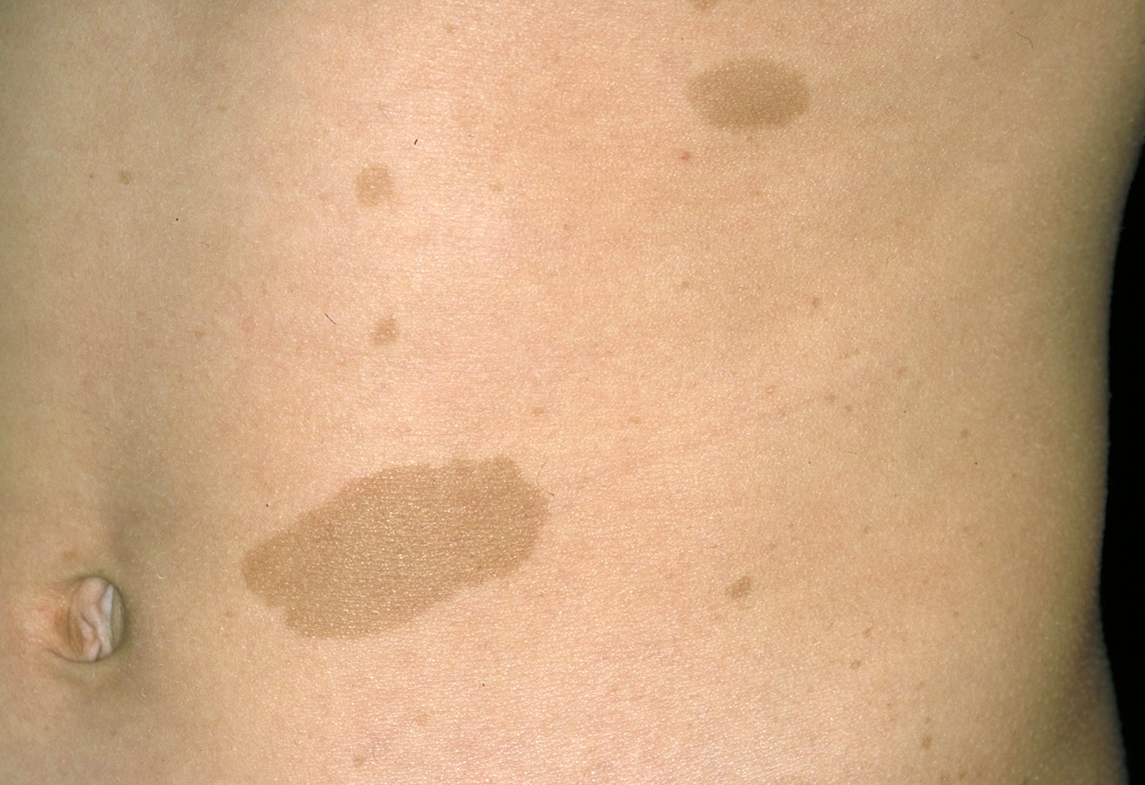 | Café au lait:  Benign  Flat light brown patches  6 required to meet diagnostic criteria  Appear by 2 years old and then increase in size and number over time
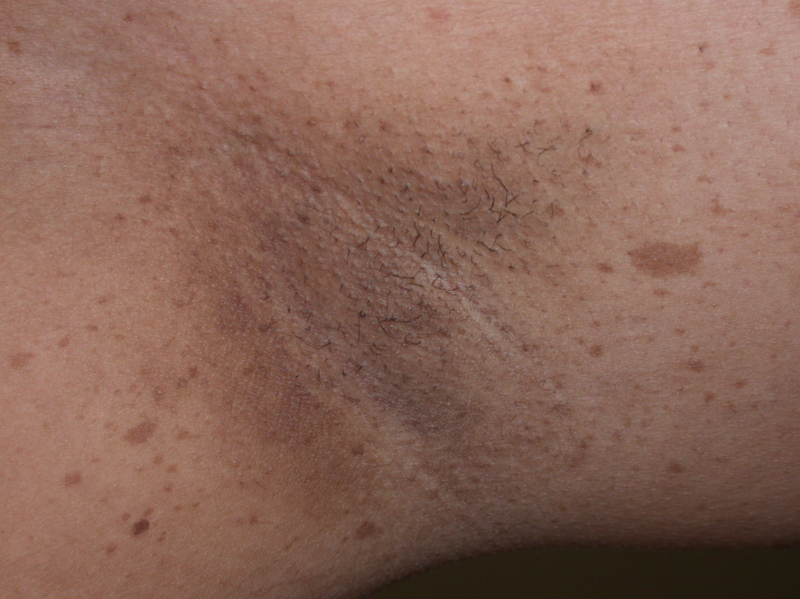 | Flexure freckling:  Freckling in non-sun-exposed areas  Benign  Diagnostic criteria for NF1
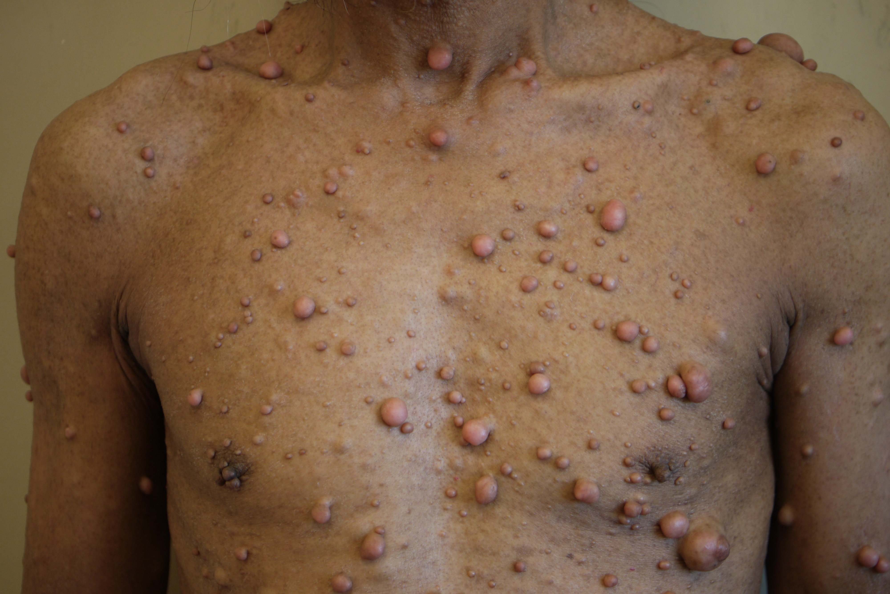 | Cutaneous neurofibroma / dermal neurofibroma  Benign tumours of peripheral nerves in the skin  No potential for malignant change  Removed for cosmetic reasons or if causing discomfort  (In contrast: subcutaneous neurofibroma: less visible, bumps in the skin; cause pain and paraesthesia; rarely undergo malignant transformation.)
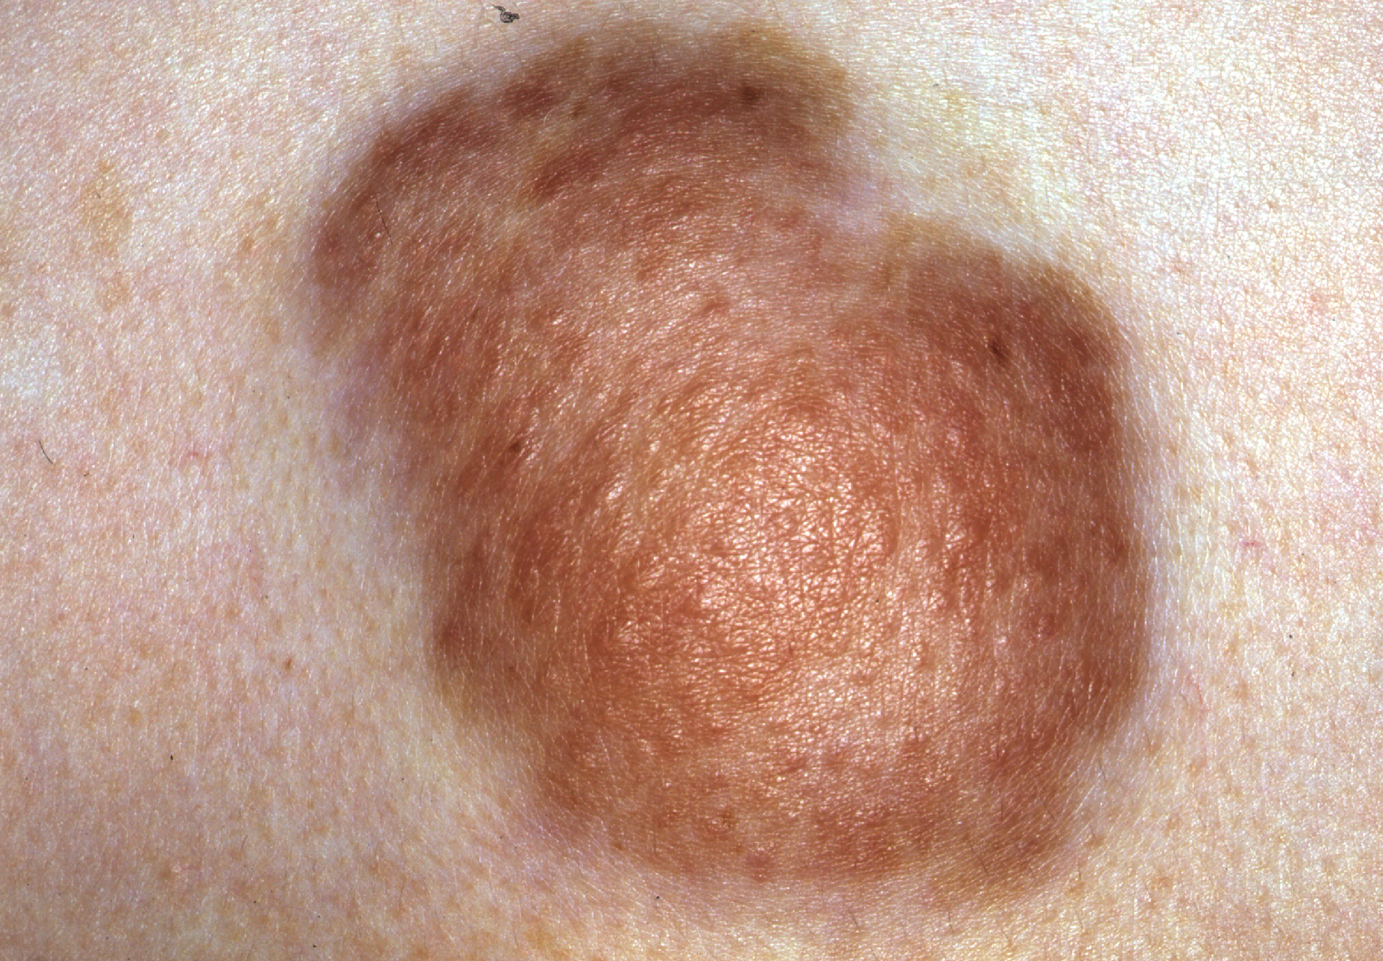 | Plexiform neurofibroma  Not visible initially; internal neurofibromas  Affect large nerve trunks, spinal roots or multiple nerve branches  Can infiltrate soft tissue and bone  Cause pain, disfigurement, impaired function; rarely become malignant  Sometimes overlying skin is pigmented
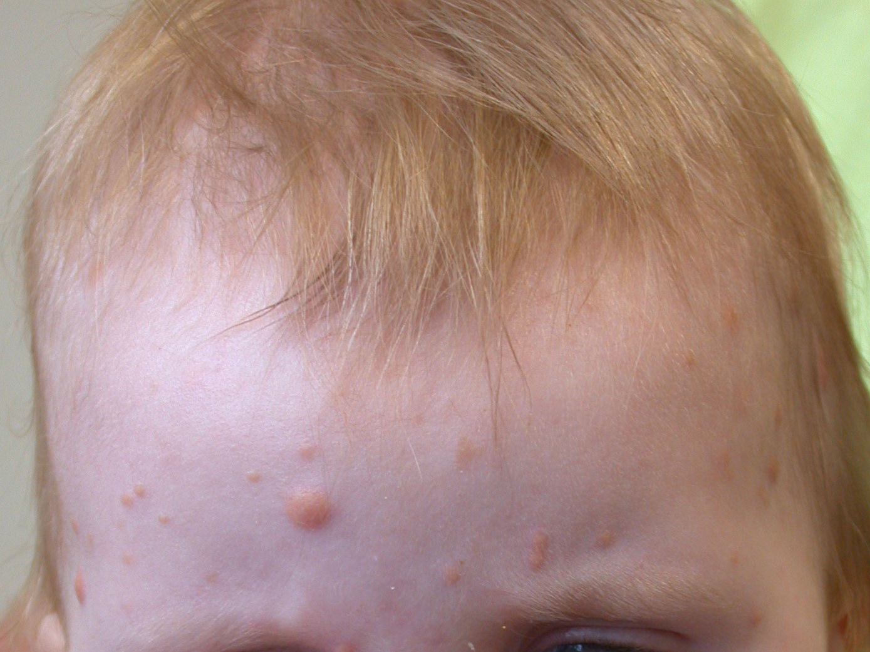 | Xanthogranuloma  Red/yellow papules, usually <0.5cm diameter (up to 2cm can occur)  May become scaly  Non-Langerhan’s cell histiocytosis  An association with CML
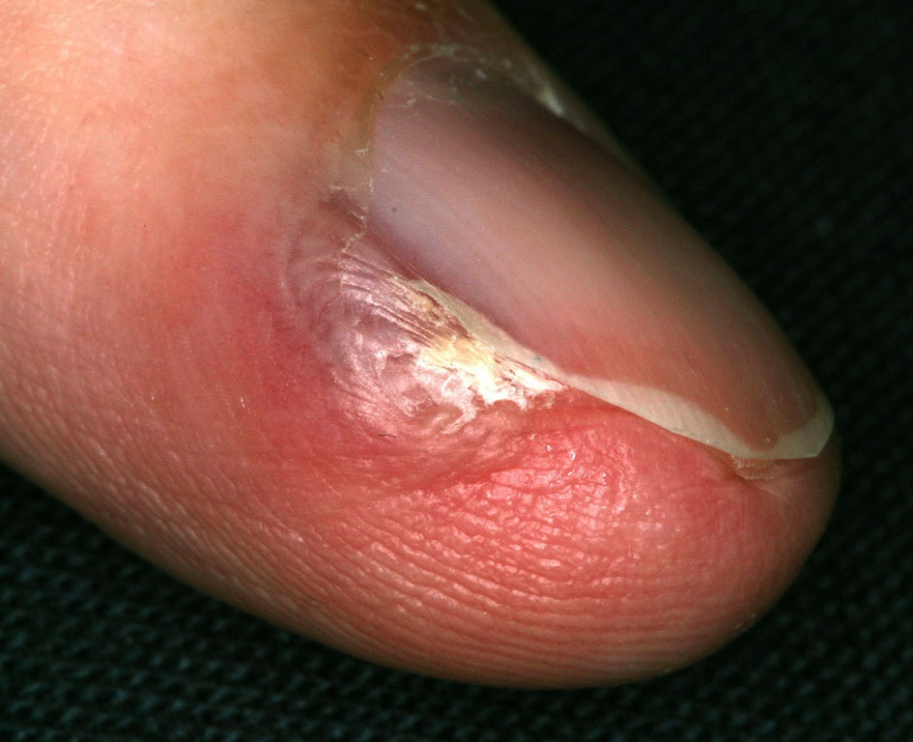 | Glomus tumours  Arise from the glomus body  Found under the nail or adjacent to it  Present as painful nail, worse on placing the finger in cold water  Blue or white in colour

Ophthalmology

Optic pathway gliomas and lisch nodules are the two main ophthalmological manifestations. Pulsating exophthalmos can occur secondary to sphenoid wing dysplasia. Lisch nodules, or iris hamartomas, are seen by slit lamp examination and are useful in diagnosis, but do not affect vision and so do not require monitoring once the diagnosis of NF1 is made.
Optic pathway gliomas are grade 1 pilocytic astrocytoma. They occur in 15% of children with NF1 and are most commonly symptomatic in children under 7 years. If symptomatic they require treatment. Treatment is chemotherapy; surgery may also be required. If the abnormality can be identified when its effects are minimal, loss of sight may be prevented
Children with NF1 require annual ophthalmology review until 7 years old to screen for signs of OPGs. The review should include:
a) Inspection for squints and proptosis
b) Visual acuity testing
c) Tests for colour vision
d) Visual field testing
e) Visualisation of the optic discs - looking for pale discs and elevation

The UK guideline is currently to screen yearly until children 7 years old, as the majority of ophthalmological problems requiring intervention first occur when the child is under 7[11] and children of this age do not report visual disturbance until severe. A number of groups suggest screening should continue up until the age of 10 or even 25 years as they can present later and the consequence of delayed treatment can be serious[6].
A sensible approach is to ensure full ophthalmological screening yearly to the age of 7 years, and beyond if symptoms are present. From the age of 8 years, if the child has severe learning and communication difficulties which may prevent symptoms being easily detected, further annual screening may be required, while in others a review every three years may be offered. Advice to seek assessment if any symptoms arise should always be given.

Neurology

Neurological complications in NF1 are wide ranging; cognitive problems which we discuss separately are the commonest. Children with NF1 often have macrocephaly; this does not require investigation unless there is rapid growth crossing the centile lines. Other complications include tumours in the central and peripheral nervous system, the complications of bony malformations, different epilepsies, sensorineural hearing loss (5%)[12], and cerebrovascular disease. Central nervous system tumours include gliomas of the optic tract, brainstem and cerebellum. Acoustic neuromas (schwannomas) are not characteristic of NF1 and occur rarely. Plexiform neurofibromas can cause pressure on spinal roots and peripheral nerves. Aqueduct stenosis can lead to raised ICP, while scoliosis can cause cord compression.
It is important to take a thorough neurological history and examination, including sensory, motor and co-ordination assessments, which should aim to elicit if present:
- Signs of peripheral nerve damage
- Upper motor neurone signs suggestive of a CNS tumour
- Cerebellar signs suggestive of a cerebellar tumour
- Symptoms of raised intracranial pressure
- Symptoms and signs of spinal cord compression

Additionally head circumference should be measured and plotted to look for increase across centile lines, and epilepsy control should be reviewed.

If there are signs of acute or progressive neurological disturbance a referral to a neurologist should be made; in the presence of signs of raised intracranial ICP, urgent imaging and a referral to a neurosurgeon should be arranged. If there is any evidence of hearing loss a referral for an audiology assessment should be made. Epilepsy occurs in 6-7% of people with NF1. This can range from infantile spasms in the infant period, which is rare, to focal seizures as children get older. Standard guidelines should be followed with an MRI at the point of diagnosis[13].

Skeletal

Bowing of the long bones - commonly the tibia- is seen in 2% in the first few months of life and is secondary to an intrinsic defect of bone formation[5]. Benign, non-ossifying fibromas can occur and be painful. Pathological fractures which are slow to heal and can lead to pseudoarthrosis can occur. NF1 is linked with decreased bone mineralisation[5]; vitamin D and or calcium supplements, should be considered in those who have suffered fractures.
Annual review should mainly focus on assessment of the spine. Both idiopathic and dystrophic scoliosis is prevalent in this population, mainly affecting the lower cervical and upper thoracic spine[14]. Idiopathic scoliosis is generally less severe and associated with fewer complications than dystrophic scoliosis, but it can develop into dystrophic scoliosis, which is associated with a greater degree of curvature and usually associated kyphosis; the threshold for surgery is lower in dystrophic scoliosis. The role of the secondary level paediatrician is to monitor for scoliosis and when found refer on to a specialist orthopedic team with experience of patients with NF1.

Physical Development

Children should be measured carefully at each visit, including height, weight and head circumference. Their pubertal status should also be assessed. Hypothalamic or pituitary disturbance may be caused by an optic pathway glioma and so cause delayed or precocious puberty. Rapidly increasing macrocephaly may indicate increasing tumour size or hydrocephalus.

Cardiovascular
Congenital heart disease, especially pulmonary stenosis, is associated with NF1. The frequency of CHD in NF1 is quoted as being anywhere from 0.4 to 6.4%, with most studies suggesting the lower end of this spectrum. An echocardiogram to assess for CHD is only necessary if a murmur is heard.
Hypertension is common in NF1 and increasingly so with age. While it is usually essential hypertension there are a number of important differentials which occur at higher frequency: coarctation of the aorta, renal artery stenosis and phaeochromocytoma[15]. In view of this:
- Assess blood pressure annually.
- Arrange an echocardiogram in all children with hypertension or differences between pulses / pressures between limbs to screen for coarctation.
- If echo is normal arrange a renal ultrasound with Doppler.
- Consider testing for phaeochromocytoma if hypertension is refractory to treatment or if there are symptoms of catecholamine excess but note that phaeochromocytomas rarely present in childhood.

NF1 is associated with a vasculopathy with unknown frequency. Aneurysms, stenoses, occlusions, ruptures and fistulae are all seen[15]. The most common feature is renal artery stenosis which would be diagnosed when investigating hypertension. Any acute neurological deterioration in a patient with NF1 should raise the suspicion of cerebrovascular disease; in children acute deficits usually reflect thrombo-embolic events.

Other systems dependent on symptoms

Further examination or tests of other systems may be necessary depending on what has been discovered in the history and from the other systems. Abdominal examination is not needed routinely at annual review, but if symptoms such as pain, bloating or GI bleeding are reported or anaemia is under investigation, then the abdomen should be examined and possibly imaged as both gastrointestinal neurofibromas and stromal tumours can occur in NF1[5,16].

Education and behaviour
The annual review offers an important opportunity to review school performance and behaviour. Specific learning problems are observed in 30-60% of children[17] and these cognitive problems persist into adulthood. IQ is often in the low average range, with an overall IQ of 70 or less being rare. Attention difficulties, hyperactivity and autistic spectrum disorder all occur at increased frequency [18].
At annual review questions should be asked about school progress,(including reviewing the report and contacting the school where necessary for more information), sleep patterns, concentration, distractibility, social interaction and fine / gross motor skills. If problems are identified a referral for a detailed evaluation should be made. The most appropriate referral will depend on the problems identified, but may include educational/clinical psychology, a community paediatrician, family therapy or a neurologist. Early identification of such problems enables appropriate support and strategies to be put in place which may change the outcome for that child. Attention deficit in NF1 has been shown to respond to cognitive behavioural therapy and methylphenidate[18]. A special educational needs coordinator needs to be involved

Psychological

The psychological burden of NF1 is significant. Patients may struggle as they grasp the implications of their diagnosis and also to come to terms with the disfigurement caused by neurofibromas which tend to develop mainly in late adolescence. Psychological problems will often become apparent during discussion of educational progress and behaviour. In older children and young adults, it is important to ask about symptoms of depression/anxiety and consider referral to counseling or psychiatric services. A referral to a plastic surgeon or dermatologist may also be appropriate if lesions which may not otherwise warrant referral are causing significant psychological distress.

Transition
Active planning needs to be undertaken from the mental age of 13 years or chronological age of 15 years, for transition through to adult services – aged 16-18 years (dependent on maturity and mental age). Ideally they should have access to a specialist dealing in neurogenetic disorders such as NF1 for their yearly review. Where this is not possible, the young adult, family and general practitioner should be empowered to take ownership of subsequent surveillance, but annual review should be continued to the age of 25 years as a minimum. It is vital that the young adult and or their carers are fully aware of what symptoms should cause them to seek medical review, and particularly what symptoms may arouse suspicion of malignant peripheral nerve sheath tumours (MPNST).
The annual follow up from 16 to 25 years gives a good opportunity for education to occur and should continue to include dermatology, ophthalmology, neurology and cardiovascular assessments. If hypertension is diagnosed in young adults, and especially if pregnant, renovascular disease should be considered; this is rarer in older patients. Phaeochromocytoma should be considered in those with hypertension arising in pregnancy or if it is refractory to treatment / associated with symptoms of catecholamine excess. The paediatrician, with help from the tertiary NF1 specialist, should summarise the recommendations in a format allowing understanding by the young adult (depending on their mental age), and appropriate carers / GP.

Extra considerations in the young adult:

All patients with NF1 who may want to consider having children should be offered a referral to clinical genetics and be told about the possibility of pre-natal and pre-implantation testing. Women also need to be counselled on the potential complications of pregnancy[19], including hypertension and the possibility that their neurofibromas may increase in size or number and may also itch more during pregnancy.
The risk of breast cancer is increased in the NF1 population. Young adults need to be informed about this risk, especially if they are going to discontinue follow up after the age of 25 years. The risk of breast cancer is increased five-fold in women aged less than 50 years and is highest at age 40 to 50 years. They fall in the “moderate risk” category and should have annual mammography from the age of 40 years[20].
There have been individual case reports of affected males; it is therefore probably wise to advise male patients to monitor themselves for breast lumps.
It is advised that annual review should continue until patients are in their mid-twenties[5] after which point further follow up will depend on disease severity and the patient’s wishes. Beyond the age of 25, an asymptomatic adult may only need an annual blood pressure check and referral to specialist services only if complications arise or if advice about pregnancy is required. However, a more severe case may need continued hospital follow up, as discussed above.
Within the authors’ own practice, we recommend that when young adults reach the age of 25 years they request an annual meeting with their general practitioner, but note the lack of guideline supporting this.

Concluding the consultation
NF1, with its multiple complex manifestations, can cause substantial parental anxiety and can prove to be a social, emotional and economic burden to the family. Families will often have many questions to ask when they come for review. Patient organisations such as the NF Association can be invaluable in providing some of the necessary support and answers to questions. Alongside welfare concerns are the more scientific queries regarding ongoing research. While a secondary care level paediatrician would not necessarily have the answers to all the questions a parent may have about ongoing research or complex management decisions, it is important that parents can be pointed to where they can find more information. We hope that this article can provide some answers to questions from parents, but very often their questions will be beyond its scope and in such cases the paediatrician should have a low threshold for contacting the regional NF expert.

Footnote: We would like to inform the reader that a complete checklist and a copy of the proforma are available online via the Eastern Paediatric Epilepsy Network: http://www.networks.nhs.uk/nhs-networks/eastern-paediatric-epilepsy-network

Credits

*We would like to thank Dermnet NZ who have granted us permission to reproduce the pictures used in Table 2 for which they obtained signed.
Our thanks to the Northwest Regional Genetics Service, who initially produced a downloadable diagram on annual review, facilitating the development of our service and this paper - http://www.mangen.co.uk/CubeCore/.uploads/Clinical%20Documents/Useful%20Documents/nf1_checklist.pdf

Competing Interests
None Declared.

Licence Statement

The Corresponding Author has the right to grant on behalf of all authors and does grant on behalf of all authors, an exclusive license (or non-exclusive for government employees) on a worldwide basis to the BMJ Group and co-owners or contracting owning societies (where published by the BMJ Group on their behalf), and its Licensees to permit this article (if accepted) to be published in Archives of Disease in Childhood and any other BMJ Group products and to exploit all subsidiary rights, as set out in our license.

References

- Friedman JM. Vascular and endocrine abnormalities. In: Friedman JM, Gutmann DH, MacCollin M, Riccardi VM, eds. Neurofibromatosis. Phenotype, Natural History, and Pathogenesis. Baltimore, MD: Johns Hopkins University Press; 1999:274-96.

- Evans DG. Neurofibromatosis type 2 (NF2): A clinical and molecular review. Orphanet J Rare Dis. 2009; 4: 16

- Ruggieri M, Huson SM. The clinical and diagnostic implications of mosaicism in the neurofibromatoses. Neurology. 2001; 56(11):1433-43.

- NIH; National Institutes of Health Consensus Development Conference Statement: neurofibromatosis. Bethesda, Md, USA, July 13-15, 1987. Neurofibromatosis. 1988;1:172–8.

- Ferner RE, Huson SM, Thomas N et al. Guidelines for the diagnosis and management of individuals with Neurofibromatosis 1 (NF1). J Med Genet. 2007; 44:81–8.

- King A, Listernick R, Charrow J et al. Optic pathway gliomas in neurofibromatosis type 1: the effect of presenting symptoms on outcome. Am J Med Genet A. 2003;122A:95–9

- Listernick R, Ferner RE, Liu GT et al. Optic pathway gliomas in neurofibromatosis-1: controversies and recommendations. Ann Neurol. 2007;61:189–98

- Sabol Z, Resić B, Gjergja Juraski R et al. Clinical sensitivity and specificity of multiple T2-hyperintensities on brain magnetic resonance imaging in diagnosis of neurofibromatosis type 1 in children: diagnostic accuracy study. Croat Med J. 2011;52:488–96

- Kim DH, Murovic JA, Tiel RL et al. A series of 397 peripheral neural sheath tumors: 30-year experience at Louisiana State University Health Sciences Center. J Neurosurg. 2005;102:256–66.

- De Smet L, Sciot R, Legius E. Multifocal glomus tumours of the fingers in two patients with neurofibromatosis type 1. J Med Genet 2002;39:e45.

- Listernick R, Gutmann DH. Tumors of the optic pathway. In: Friedman JM, Gutmann DH, MacCollin M, Riccardi VM, eds. Neurofibromatosis: Phenotype, Natural History, and Pathogenesis. Baltimore, MD: Johns Hopkins University Press; 1999:203-30.

- Pensak ML, Keith RW, Dignan PS et al. Neuroaudiologic abnormalities in patients with type 1 neurofibromatosis. Laryngoscope. 1989;99(7 Pt 1):702-6.

- Vivarelli R, Grosso S, Calabrese F et al. Epilepsy in neurofibromatosis 1. J Child Neurol 18:338–42.

- Crawford A HJr, Bagamery N. Osseous manifestations of neurofibromatosis in childhood. J Pediatr Orthop1986;6:72–88.

- Friedman JM, Arbiser J, Epstein JA et al. Cardiovascular disease in neurofibromatosis 1: report of the NF1 Cardiovascular Task Force. Genet Med. 2002:4(3):105-11

- Miettinen M, Fetsch JF, Sobin LH et al. Gastrointestinal stromal tumors in patients with neurofibromatosis 1: a clinicopathologic and molecular genetic study of 45 cases. Am J Surg Pathol. 2006;30:90–6

- Hyman S L, Shores A, North K N. The nature and frequency of cognitive deficits in children with neurofibromatosis type 1. Neurology 2005;11:1037–44

- Mautner V F, Kluwe L, Thakker S D et al. Treatment of ADHD in neurofibromatosis 1. Dev Med Child Neurol 2002;44:164–70

- Dugoff L, Sujansky E. Neurofibromatosis type 1 and pregnancy. Am J Med Genet. 1996;66:7–10.

- Sharif S, Moran A, Huson SM et al. Women with neurofibromatosis 1 are at a moderately increased risk of developing breast cancer and should be considered for early screening. J Med Genet. 2007;44:481–4.

Figure legends:

Figure 1: NF1 Timeline. This figure illustrates at what ages different disease manifestations become apparent.
Figure 2: An annual review checklist proforma for children aged 0 to 16 years.
Figure 3: An annual review checklist proforma for young adults aged 16 to 25 with particular emphasis to be noted on education being especially important during the transition period to adult services.

