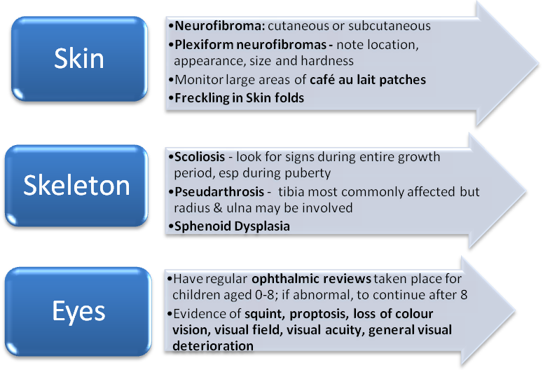

Referral for cosmetic purposes or rapidly growing, painful or changing lesions: ur-gent referral to spec-ialist sarcoma team. Also for

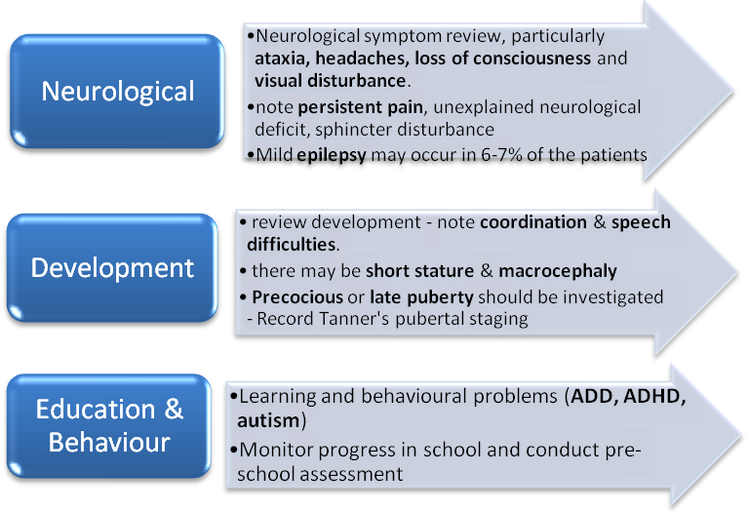
Any curvature or bowing, refer to orthopaedic surgeon
Urgent referral to ophthalmologist if there are concerns about the visual symptoms
If symptomatic, referral to neurologist for further investigations
Consider professional assessment of education needs or referral to MDT
Referral made to endocrinologists if abnormal pubertal status
