My Epilepsy Care Plan  Your Trust Logo here  NHS No: |  |  |  | 
ABOUT ME
1.1 | My Name
1.2 | My date of birth
1.3 | My Address
1.4 | My Emergency Contacts
PROFESSIONALS INVOLVED IN MY CARE
2.1 | My GP
2.2 | My Epilepsy Nurse
2.3 | My Epilepsy Doctor
2.4 | My School/Nursery
ABOUT MY EPILEPSY
3.1 | My Diagnosis
3.2 | My Regular Medications  Doses change with weight so please check

EMERGENCY SEIZURE PLAN AND MEDICATION
3.3 | My Emergency Medication  Instructions of when to administer below |  | Buccal Midazolam 1st Dose 2nd Dose  Prescriber: Name Signature Date  ………………………… …………………………….. ……………….  Rectal Paraldehyde 1st Dose 2nd Dose  Prescriber: Name Signature Date  ………………………… …………………………….. ……………….
3.4 | Seizure type 1  Generalised Tonic-Clonic Seizure (convulsive) |  | Known Triggers  Description  Duration/frequency  Recovery  Emergency Medication Describe which medication should be administered and when  Important info
3.5 | Seizure type 2  Convulsive/non convulsive |  | Known Triggers  Description  Duration/frequency  Recovery  Emergency Medication Describe which medication should be administered and when  Important info
CARE PLAN AGREED BY
Epilepsy Nurse  Name |  | Sign:  Date: |  | Epilepsy Consultant  Name | Sign:  Date:
Parent/Carer  Name |  | Sign:  Date: |  | Representative from school or nursery (if appropriate) | Sign:  Date:
Care plans with emergency medication are routinely reviewed at 12 month intervals, unless there is a change to the emergency protocol (in which case the plan should be updated to reflect this). Please note that this is a guideline and care plans do not expire, so please do not refuse children to attend school or participate in any activity due to a care plan review date passing. Epilepsy teams ask that parents also take joint responsibility for getting reviews of plans in a timely manner. If you notice that this plan was reviewed more than 12 months ago then please ask the child’s parents to contact their epilepsy team to request a non-urgent review, and continue to use this plan until the review is undertaken.

WHAT TO DO IF I HAVE A SEIZURE – FIRST AID
4.1 | If I have a convulsive seizure  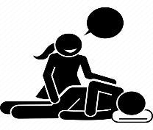 | - Ensure that I am in a safe environment (e.g. not exposed to traffic) and remove dangerous objects from my space  - Place me on my side if/when possible and support my head to prevent injury, but do not restrain me  - Note the time the seizure began, time the duration  - Monitor my breathing at all times  - Do not put anything in my mouth  - If safe to do so record a video of the event
4.2 | If I have a non-convulsive seizure  Focal/Absence | - Do not try to stop the seizure  - Stay with me throughout the seizure and call for help if needed  - Lead me to a place of safety and privacy  - Offer me verbal reassurance, repeat things that I may have missed  - Note length of seizure and record
4.3 | When to call 999 for an ambulance | - If you are concerned that I am not breathing properly  - If you have had to give me emergency medication and my seizure has not stopped after 10 minutes  - If I have dribbled the dose out, or there is a reason that the dose was abandoned  - If I have injured myself  - If you are concerned
4.4 | What to do after a seizure | - Place me in the recovery position (on my side) if appropriate.  - Stay with me and offer lots of reassurance.  - Record the time and duration of the seizure (how long it lasted for).  - If you are concerned I have not recovered fully call an ambulance.  - If you are happy that I am fully recovered, inform my parents or keep a record of the seizure in my Seizure Diary depending on previous advice.

HOW TO ADMINISTER BUCCAL MIDAZOLAM (Epistatus)
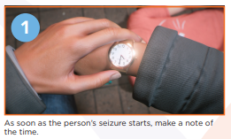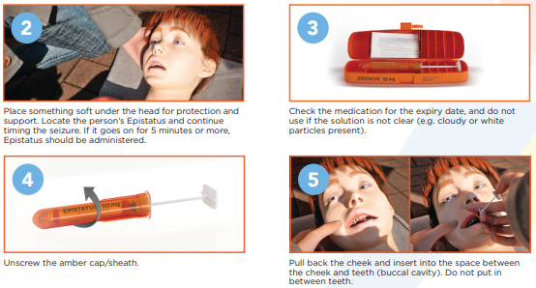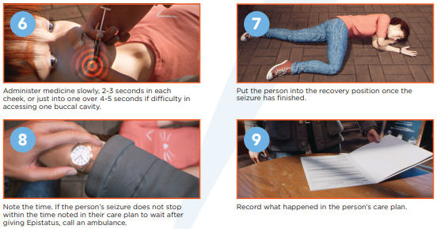

HOW TO ADMINISTER PARALDEHYDE
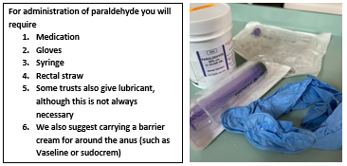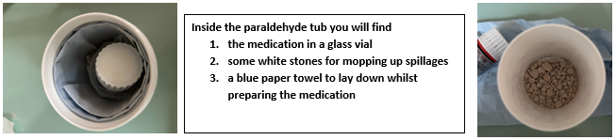

Rectal Paraldehyde
- It will take a few minutes to get this all organised so it is best to prepare ahead of time. Paraldehyde has a strong smell (this is normal)
- Apply gloves, check expiry date of medication (if expired call 999 and do not give)
- Attach syringe to the tube and draw up the correct dose (see section 3.3)

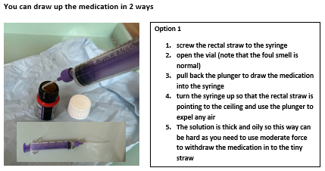

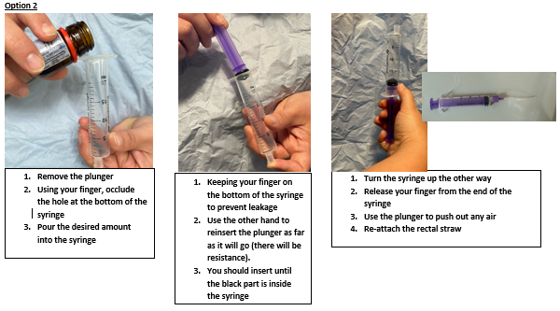

- Place onto side and remove clothing (ensure privacy)
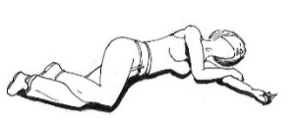
- Insert the tube into the back passage about 4cms and push the plunger to empty the full amount into the rectum.
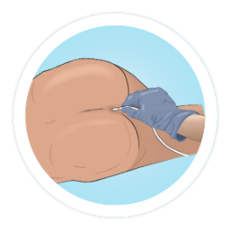
- Withdraw the tube and push bum cheeks together to prevent leakage

Paraldehyde will start to melt plastic after 10 minutes so any medication that is drawn up and not used MUST be discarded after 10 minutes

FURTHER INFORMATION – SEIZURE SAFETY
5.1 | For healthcare professionals  Paramedics/hospitals | On arrival in hospital please treat status epilepticus as per APLS Guidelines https://www.apls.org.au/algorithm-status-epilepticus  Add Specific instructions here – such as resp depression with benzos, or bespoke plans for ambulance and A&E staff here
5.2 | Safety advice for schools | Epilepsy increase the risk of accidents and injury, as during a seizure I might fall down, lose consciousness, or have muscle movements that I can’t control. Not everyone has the same level of risk, and seizure type and frequency are important factors. Activities involving Heights, Traffic, Water, Sources of heat or power increase the risk. It is important that all children (despite the diagnosis of epilepsy) are encouraged and enabled to participate in all activities, individual risk assessments in your areas should include the following questions  - How often does the child/young person have seizures – are they frequent?  - What happens during a seizure – does the seizure cause the child to fall, jerk or wander?  - Where the child/young person is – are they in a road, near water or other hazards?  - What they are doing – are they climbing, running, cycling, cooking, using scissors?  - Who they are with – are they with someone trained in seizure safety / first aid?  For further information please visit:  https://www.epilepsy.org.uk/info/daily-life/safety.  https://www.epilepsypace.org.uk  https://www.epilepsy.org
5.3 | Safety Advice for seizures in water | As a general rule, children with epilepsy should be encouraged to take part in swimming. A designated person must be allocated to observe the child whilst in the water (at all times). If a seizure occurs in the water, then please follow this advice:  Convulsive seizures  From behind, tilt the child’s head so it is out of the water.  If possible, move the child to shallow water.  Shout for a lifeguard to help you get the child out of the water.  Once the child is out of the water, follow the above first aid advice for convulsive seizures.  Non Convulsive seizures  Protect the person from danger, for example by guiding them away from deep water or by holding their head above the water. When they recover, check if they need to get out of the water as they may feel confused and need to rest.
5.4 | Training for Schools | Please be aware that the children and families act 2014 places a legal responsibility on schools to access training for children with epilepsy. It is not the epilepsy team’s responsibility to fulfil this obligation, and due to the large caseloads that we support in the hospital, it is not possible to train every school in basic epilepsy awareness, and you should approach your school nursing team if you need this. We recommend all school staff undertake the following free online training: https://learn.epilepsy.org.uk/courses/epilepsy-for-teachers/ Please contact the epilepsy nurse for a discussion around the child’s individual care plan if the child is receiving rescue medication, but please note that this will only be offered as a virtual meeting once the above course has been completed and certificate sent by email.
5.5 | Advice for parents | Online Epilepsy Course for parents (free)  https://learn.epilepsy.org.uk/courses/your-child-and-epilepsy/  Seizure alarms – we do not fund or endorse any particular brand of seizure alarm due to the lack of evidence around the reliability of monitors, and a simple baby monitor with a camera can be used. You can view the available alarms on the market here:  https://www.epilepsy.org.uk/living/safety-equipment/alarms-and-monitors  https://www.youngepilepsy.org.uk/sites/default/files/dmdocuments/Night-safety-equip-126-2%20(1).pdf  SUDEP – this is a rare complication of epilepsy. To read about this and learn how to manage risks  https://sudep.org/  Further Reliable resources  https://www.epilepsy.org.uk/  https://www.youngepilepsy.org.uk/

